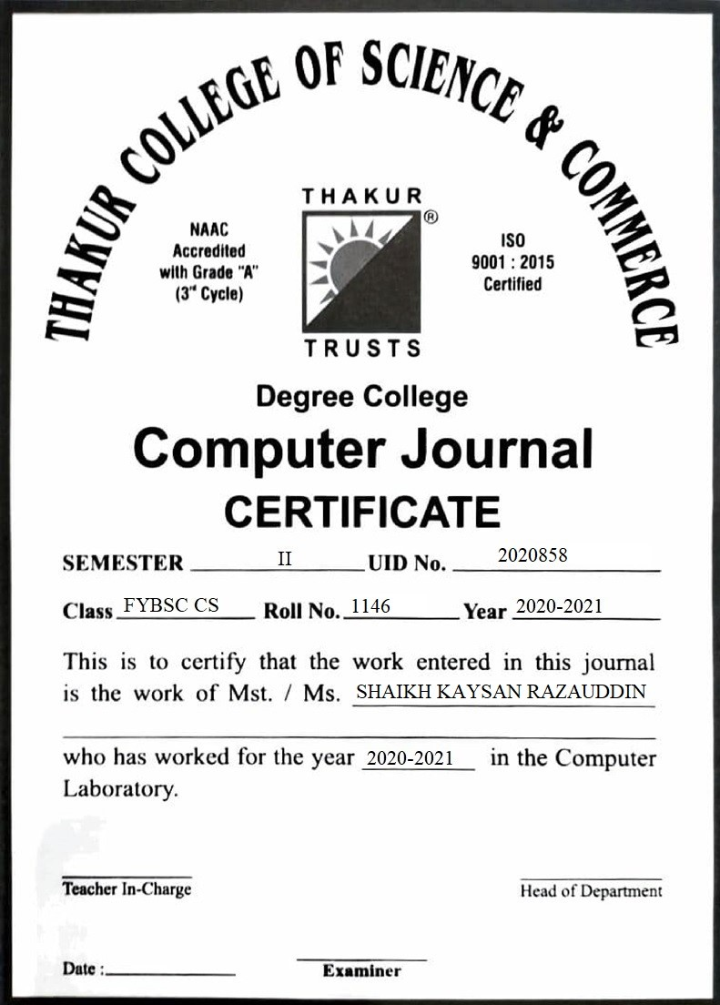

|  |  |  |  |
| --- | --- | --- | --- |
| **Sr. no.** | **Title** | **Date** | **Page**  **No.** |
| **1.** | Identify any Open Source software and create detailed report about it. | 27/03/2021 | 3 |
| **2.** | Learn at least three different open source licenses and create a brief report about them. | 03/04/2021 | 6 |
| **3.** | Explain how to Create GitHub account. | 10/04/2021 | 15 |
| **4.** | MySQL: Statements to create table student. | 17/04/2021 | 22 |
| **5.** | Demonstrate the use of all keywords use select command after adding 10 records. | 24/04/2021 | 28 |
| **6.** | Contributing to Wikipedia. | 26/04/2021 | 38 |

**Practical No: 01**

**Blender**



**Aim:** Identify any Open Source software and create detailed report about it.

**A) Idea:**

The **Blender** Foundation was **created** in 2002 is an independent public benefit organization with the purpose to provide a complete, free and open-source 3D creation pipeline, managed by public projects on **blender**.org so as a nonprofit organization they can’t sell **blender** to users because of the nature of non-profit, but they can make money through other means.

**B) What problem does it solves?**

Blender comes with its two very powerful rendering options.

1. Eevee
2. Cycles

Eevee is a physically based real time rendering engine. This allows for rendering of final scenes or to edit models in real time.

This is extremely useful as you do not need to rely on long render to see the final result of your model. Not to mention bugs are fixed faster and the usability is always getting better.

**C) Licensing Model:**

Blender is released under the GNU General Public License (GPL, or “free software”).

This license grants people a number of freedoms:

* You are free to use Blender, for any purpose
* You are free to distribute Blender
* You can study how Blender works and change it
* You can distribute changed versions of Blender

**D) Intent behind making it open source:**

In May 2002, Roosendaal started the non-profit [Blender Foundation](https://en.wikipedia.org/wiki/Blender_Foundation), with the first goal to find a way to continue developing and promoting Blender as a community-based [open-source](https://en.wikipedia.org/wiki/Open-source_software) project. On July 18, 2002, Roosendaal started the *"Free Blender"* campaign, a [crowdfunding](https://en.wikipedia.org/wiki/Crowdfunding) precursor. The campaign aimed at open-sourcing Blender for a one-time payment of €100,000 (US$100,670 at the time), with the money being collected from the community. On September 7, 2002, it was announced that they had collected enough funds and would release the Blender [source code](https://en.wikipedia.org/wiki/Source_code). Today, Blender is [free](https://en.wikipedia.org/wiki/Free_software) and open-source software, largely developed by its community as well as 24 employees employed by the Blender Institute.

**E) Monetization Models:**

Blenders business model is different to that of its competitors its main sources of income include donations, merchandise sales and a Cloud Service.

**F) Popularity:**

**The largest group in Blender’s audience is 18 to 24 year old males.** This data has been compared against samples from other platforms (social media channels, YouTube analytics) and the metrics are very similar. Social Media Following. Blender has a large social media following, with over 500K YouTube subscribers.

**G) Impact:**

One of the driving impact of the Blender project is independence. For this reason, through over 15 years of existence as Free Software project,**Blender has operated a number of self-hosted web platforms to serve its community.**

**Practical No: 02**

**Aim:** Learn at least three different open source licenses and create a brief report about them.

1. **GNU General Public License**

The GNU General Public License (GNU GPL or simply GPL) is a series of widely-used free software licenses that guarantee end users the freedom to run, study, share, and modify the software. The licenses were originally written by Richard Stallman, founder of the Free Software Foundation (FSF), for the GNU Project, and grant the recipients of a computer program the rights of the Free Software Definition.

**A) History of License:**

The license was originally called the **GNU Library General Public License** and was first published in 1991, and adopted the version number 2 for parity with GPL version 2. The LGPL was revised in minor ways in the 2.1-point release, published in 1999, when it was renamed the GNU Lesser General Public License to reflect the FSF's position that not all libraries should use it. Version 3 of the LGPL was published in 2007 as a list of additional permissions applied to GPL version 3.

In addition to the term "work based on the Program" of GPL, LGPL version 2 introduced two additional clarification terms "work based on the library" and a "work that uses the library". LGPL version 3 partially dropped these terms.

**B) IDEA:**

The GPL (The GNU General Public License), created by Richard Stallman, serves as the de factoconstitution for the Free Software movement. It covers the majority of Free Software/Open Source software

The **GNU** **Lesser** **General** **Public** **License** (LGPL) was created to have a weaker copyleft than the **GPL**, in that it does not require own custom-developed source code (distinct from the LGPL'ed parts) to be made available under the same **license** terms.

**What Problem Does It Solves?**

**Version 1**

Version 1 of the GNU GPL, released on 25 February 1989, prevented what were then the two main ways that software distributors restricted the freedoms that define free software. The first problem was that distributors may publish binary files only—executable, but not readable or modifiable by humans. To prevent this, GPLv1 stated that copying and distributing copies or any portion of the program must also make the human-readable source code available under the same licensing terms.

**Version 2**

According to Richard Stallman, the major change in GPLv2 was the "Liberty or Death" clause, as he calls it – Section 7. The section says that licensees may distribute a GPL-covered work *only* if they can satisfy all of the license's obligations, despite any other legal obligations they might have. In other words, the obligations of the license may not be [severed](https://en.m.wikipedia.org/wiki/Severability) due to conflicting obligations. This provision is intended to discourage any party from using a patent infringement claim or other litigation to impair users' freedom under the license.

**C) Which Popular Software are released under this license?**

* Akvo platform - data platform for sustainable development goals and international development tracking
* Alaveteli
* Ampache - web based audio/video streaming application
* Anki - the desktop version is under GNU AGPL, the Android version is under GPLv3.0
* Bacula
* BEdita 3 Open

**D) Popular News Associated with GNU License:**

on April 11th we announced the publication of Interpreting, enforcing and changing the GNU GPL, as applied to combining Linux and ZFS, by FSF founder and president, Richard M. Stallman. ... We know that many people rely on materials like the GPL FAQ and our list of licenses.

**E) Popularity:**

Popularity of individual open source license usage is tracked by several entities with the results published online. I thought it would be interesting to combine the license types that are similar and map out the overall popularity along with OSI and FSF approval and GPL compatibility. As you can see, the GPL/LGPL is the most popular license by a wide margin with over 45% of software being licensed under one or more versions. The next 3 licenses are all GPL compatible in some way meaning 67% to 87% or more of all open source code is GPL compatible and can be added to GPL licensed projects. Note that you can't tell exactly as some version issues enter into the mix with the Apache and Perl licenses.

**F) Impact:**

It has actually had a tremendous impact. First, many very common UNIX applications, such as GNU Emacs, have been released under the GPL, and are used by countless numbers of users every day. Second, the open-source software movement has taken several ideas promoted by the GPL and modified them slightly.

1. **Apache License**

The Apache License is a [permissive](https://en.wikipedia.org/wiki/Permissive_free_software_licence) [free software license](https://en.wikipedia.org/wiki/Free-software_license) written by the [Apache Software Foundation](https://en.wikipedia.org/wiki/Apache_Software_Foundation)(ASF).[[6]](https://en.wikipedia.org/wiki/Apache_License#cite_note-nmr-permissive-6) It allows users to use the software for any purpose, to distribute it, to modify it, and to distribute modified versions of the software under the terms of the license, without concern for [royalties](https://en.wikipedia.org/wiki/Royalties). The ASF and its projects release their software products under the Apache License. The license is also used by many non-ASF projects.

**A) History of license:**

Beginning in 1995, the Apache Group (later the Apache Software Foundation) released successive versions of [their well-known httpd server](https://en.wikipedia.org/wiki/Apache_HTTP_Server). Their initial license was essentially the same as the old 4-clause [BSD license](https://en.wikipedia.org/wiki/BSD_licenses), with only the names of the organizations changed. It has an extra term that extends from BSD clause 4, saying that derivatives must not bear the same Apache name.

In July 1999, Berkeley accepted the argument put to it by the Free Software Foundation and retired their *advertising clause* (clause 3) to form the new 3-clause BSD license. In 2000, Apache did likewise and created the Apache License 1.1

In January 2004, ASF decided to depart from the BSD model and produced the Apache License 2.0. The stated goals of the license included making it easier for non-ASF projects to use, improving [compatibility](https://en.wikipedia.org/wiki/License_compatibility) with [GPL](https://en.wikipedia.org/wiki/GNU_General_Public_License)-based software, allowing the license to be included by reference instead of listed in every file, clarifying the license on contributions, and requiring a patent license on contributions that necessarily infringe a contributor's own patents. This license requires preservation of the [copyright](https://en.wikipedia.org/wiki/Copyright) notice and [disclaimer](https://en.wikipedia.org/wiki/Disclaimer).

**B) IDEA:**

The Apache Software Foundation (ASF) is a non-profit 501 (c) (3) corporation, incorporated in Delaware, USA, in June of 1999. The ASF is a natural outgrowth of The Apache Group, a group of individuals that was initially formed in 1995 to develop the**Apache HTTP** Server.

The ASF's objectives are: to provide legal protection to volunteers working on Apache projects; to prevent the *Apache* brand name from being used by other organizations without permission.

**C) What Problem Does It Solves?**

* The source code of Apache is available for free to anyone.
* It can be modified to adjust the code and also to fix errors.

**D) Which Popular Software are released under this license?**

The **Apache Tomcat** software is developed in an open and participatory environment and released under the Apache License version 2. The Apache Tomcat project is intended to be a collaboration of the best-of-breed developers from around the world

**E) Popular News Associated with APACHE License:**

### 2010

* October 20, 2010 [Media Alert: The Apache Software Foundation Announces Apache Maven Version 3.0](https://blogs.apache.org/foundation/entry/media_alert_the_apache_software1)
* October 6, 2010 [ApacheCon Announces Keynote Presentations by Thought Leaders Dana Blankenhorn of ZDNet, Daniel Crichton of NASA Jet Propulsion Laboratory, and Bob Sutor of IBM Corporation](https://blogs.apache.org/foundation/entry/apachecon_announces_keynote_presentations_by)
* September 22, 2010 [The ASF Hits its Millionth Commit!](https://blogs.apache.org/foundation/entry/the_asf_hits_its_millionth)
* September 11, 2010 [Announcing The New ASF Executive Officers](https://blogs.apache.org/foundation/entry/announcing_the_new_asf_board)
* September 9, 2010 [The ASF is seeking a part-time Executive Assistant](https://blogs.apache.org/foundation/entry/the_asf_is_seeking_a)
* August 30, 2010 [Registration Opens for ApacheCon North America 2010](https://blogs.apache.org/foundation/entry/registration_opens_for_apachecon_north)

### 2009

* November 4th, 2009 [ApacheCon US 2009 Draws Unprecedented Support From the Global Open Source Community and Recognition for the 10th Anniversary and Influence of The Apache Software Foundation](https://www.apache.org/foundation/press/pr_2009_11_04_2.html)  
  Hundreds of attendees with support from dozens of corporate sponsors, exhibitors, and community partners helped make this year's ApacheCon US among the most popular events to date. The ASF was honored by the State of California and the City of Oakland; November 4 named Apache Software Foundation Day. Read the Press Release [Read More](https://www.apache.org/foundation/press/pr_2009_11_04.html) about our tenth anniversary celebration.

**F) Popularity:**

The Apache License is recognised by the Open Source Initiative as a popular and **widely deployed licence** with a strong community. All of The Apache Software Foundation’s projects, including the Apache HTTP Server project whose software powers more than half of the Internet’s web servers, use this licence.

**G) Impact:**

The Apache License is recognised by the Open Source Initiative as a popular and widely deployed licence with a strong community. All of The Apache Software Foundation’s projects, including the Apache HTTP Server project whose software powers more than half of the Internet’s web servers, use this licence.

1. **Shareware License**

Shareware is**a type of proprietary software which is initially provided free of charge to users, who are allowed and encouraged to make and share copies of the program.** Shareware is often offered as a download from a website or on a compact disc included with a magazine. Shareware differs from freeware, which is software distributed at no cost to the user but without source code being made available; and open-source software, in which the source code is freely available for anyone to inspect and alter.

**A) History of license:**

In 1982, [Andrew Fluegelman](https://en.wikipedia.org/wiki/Andrew_Fluegelman) created a program for the IBM PC called [PC-Talk](https://en.wikipedia.org/wiki/PC-Talk), a [telecommunications](https://en.wikipedia.org/wiki/Modem) program, and used the term *freeware*; he described it "as an experiment in economics more than altruism".[[9]](https://en.wikipedia.org/wiki/Shareware#cite_note-magid198208-9) About the same time, [Jim "Button" Knopf](https://en.wikipedia.org/wiki/Jim_Knopf) released [PC-File](https://en.wikipedia.org/wiki/PC-File), a [database](https://en.wikipedia.org/wiki/Database) program, calling it *user-supported software*.[[10]](https://en.wikipedia.org/wiki/Shareware#cite_note-10) Not much later, [Bob Wallace](https://en.wikipedia.org/wiki/Bob_Wallace) produced [PC-Write](https://en.wikipedia.org/wiki/PC-Write), a word processor, and called it *shareware*. Appearing in an episode of [*Horizon*](https://en.wikipedia.org/wiki/Horizon_(UK_TV_series)) titled *Psychedelic Science* originally broadcast 5 April 1998, Bob Wallace said the idea for shareware came to him "to some extent as a result of my [psychedelic experience](https://en.wikipedia.org/wiki/Psychedelic_experience)".[[11]](https://en.wikipedia.org/wiki/Shareware#cite_note-11)

In 1983 [Jerry Pournelle](https://en.wikipedia.org/wiki/Jerry_Pournelle) wrote of "an increasingly popular variant" of free software "that has no name, but works thus: 'If you like this, send me (the author) some money. I prefer cash.'"[[12]](https://en.wikipedia.org/wiki/Shareware#cite_note-pournelle198307-12) In 1984, *Softalk-PC* magazine had a column, *The Public Library*, about such software. *Public domain* is a misnomer for shareware, and *Freeware* was trademarked by Fluegelman and could not be used legally by others, and *User-Supported Software* was too cumbersome. So, columnist [Nelson Ford](https://en.wikipedia.org/wiki/Nelson_Ford) had a contest to come up with a better name.

The most popular name submitted was *Shareware*, which was being used by Wallace. However, Wallace acknowledged that he got the term from an [InfoWorld](https://en.wikipedia.org/wiki/InfoWorld) magazine column by that name in the 1970s, and that he considered the name to be generic, so its use became established over *freeware* and *user-supported software*.

**B) IDEA:**

With shareware, users are encouraged to share the limited version of the software to promote larger distribution and sales. It's not synonymous with open source software, which is source code available to anyone with the software's license for the purpose of allowing collaborative effort between developers studying the code.

**C) What Problem Does It Solves?**

* Available free of cost
* helps to know about the product before buying it.

**D) Which Popular Software are released under this license?**

XnView is a multifunctional program for viewing, editing and sorting graphic files. With this utility you can convert images from one format to another, crop them and change the contrast. Available to sort photos by different parameters, as well as putting ratings for each photo. When performing the same type of action for several documents, batch processing will help, which significantly reduces the time.

**E) Popularity:**

The**popularity** of**shareware seems to have declined — the quality was often poor.** In its place came**things like adware** or**Open Source software**or**subscription-based** software It has largely been replaced by either open source software (entirely free), or by inexpensive App Store software.

**F) Impact:**

**Popular shareware** programs you may know about include WinRAR, AnyDVD, Adobe and Microsoft programs, some antivirus software and more.

**Shareware** gives the user the opportunity to try the software, and determine if it fits their needs. PageGate, WebGate, NotePager Net and NotePager are all posted as shareware

**Practical No: 03**

**Aim:** Create and publish your own open source project: Write any simple program using your choice of programming language.

**A) Create A GitHub Account:**

1. Visit the GitHub web site
2. Create an account. Enter a username, your email address and a password. Use the same email address for github login.
3. Select a plan. GitHub provides several levels of account plans but you can create unlimited public repositories with a free plan so for now, you can select that.
4. Set up SSH authentication with GitHub. Adding an SSH key to GitHub allows you to pull and push data without typing in your password all the time.

**B) 1. Click on Go to file Option and select Create new file.**

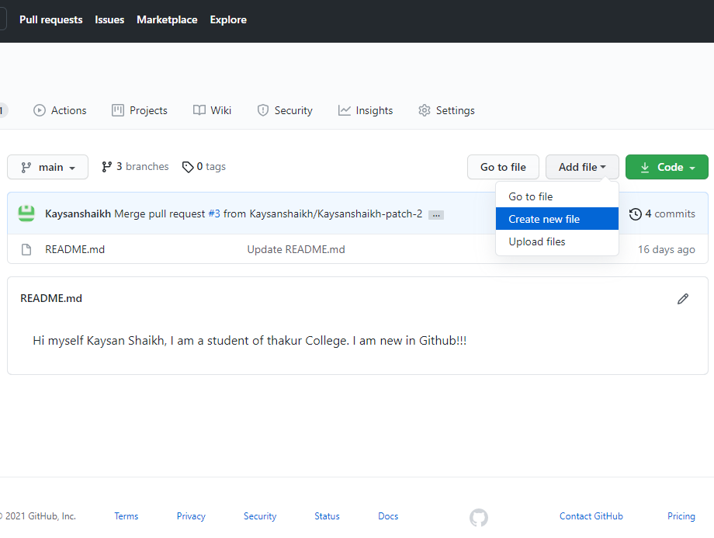

**2. You can give any name to the file and write any content you want, I give a name to the file FYBSC**

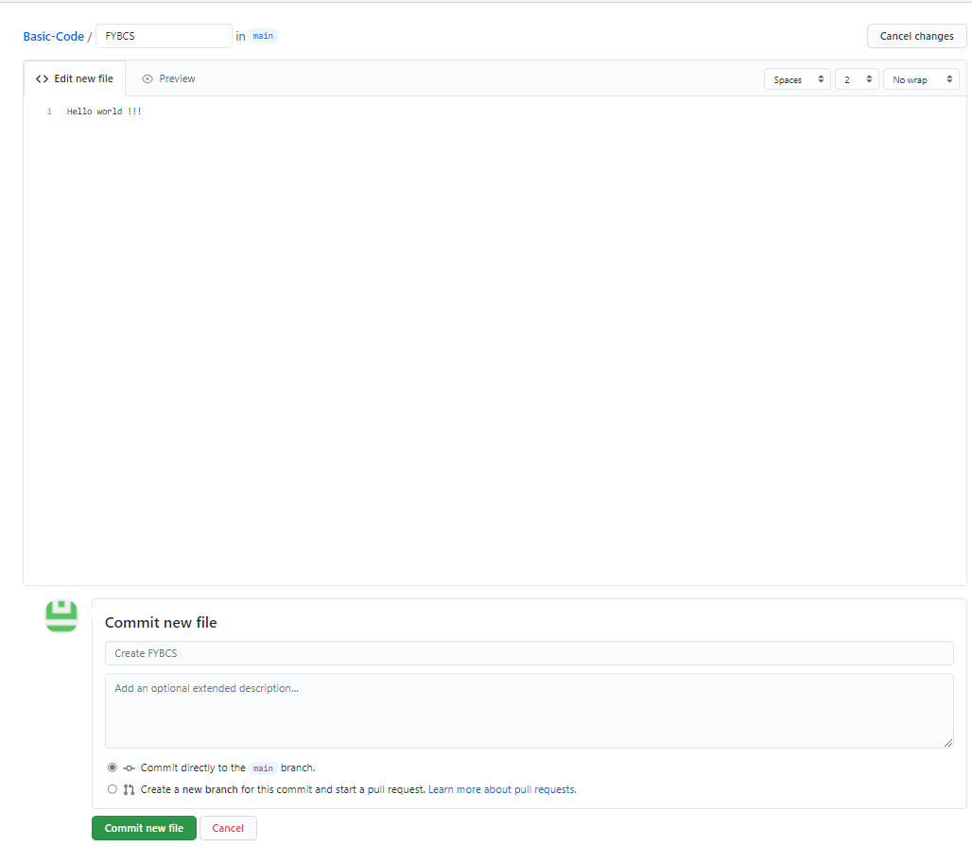

**3.Select the option ‘commit directly to the main branch’ this will be our repository.**

**4.Repository has been successfully created.**

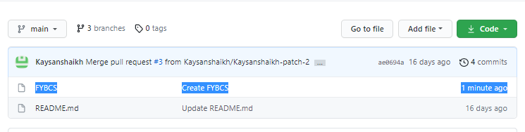

**5.Click the option ‘Create new file’**

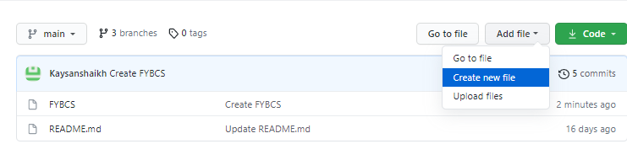

**6. I am given ‘A’ name to this file and write inside in it “This is my 3rd Practical”. You can write as per your need.**

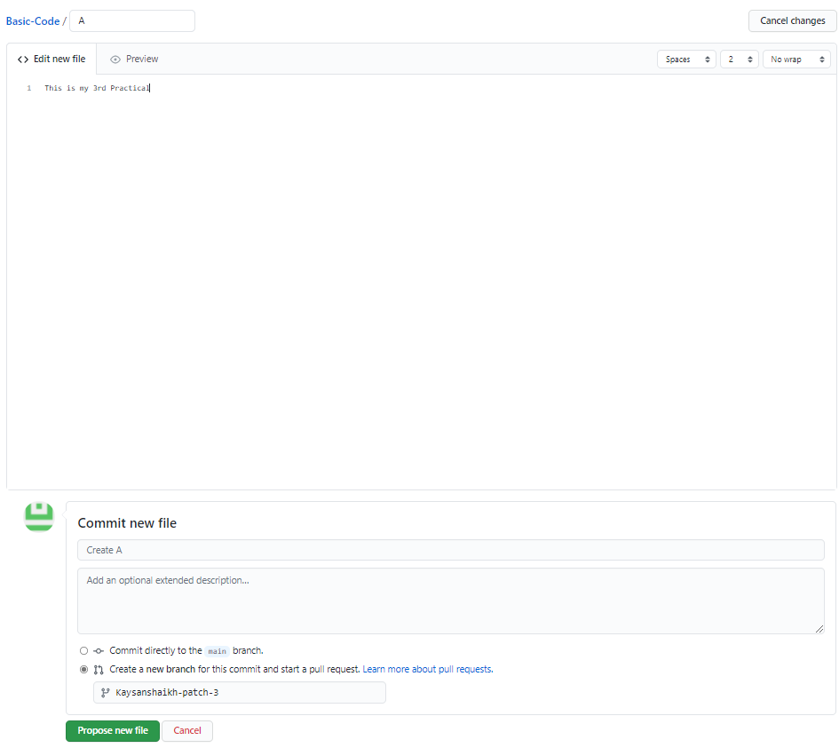

**This time will choose ‘Create a new branch for this commit and start a pull request’ this will create a branch.**

**7.Branch has been successfully created.**

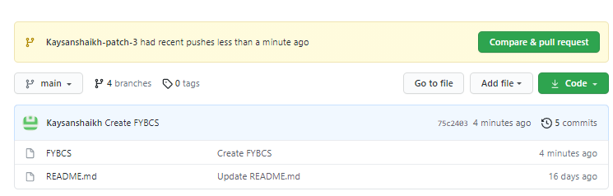

**8.Verifying the repository and branch are able to merge or not.**

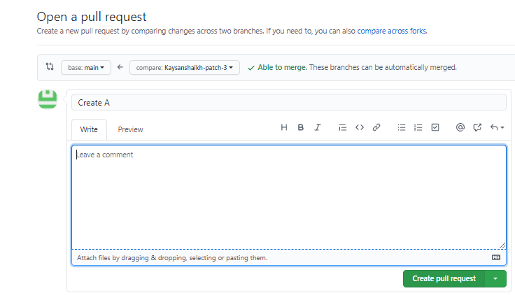

**9.Sending a Merge Pull Request for merging.**

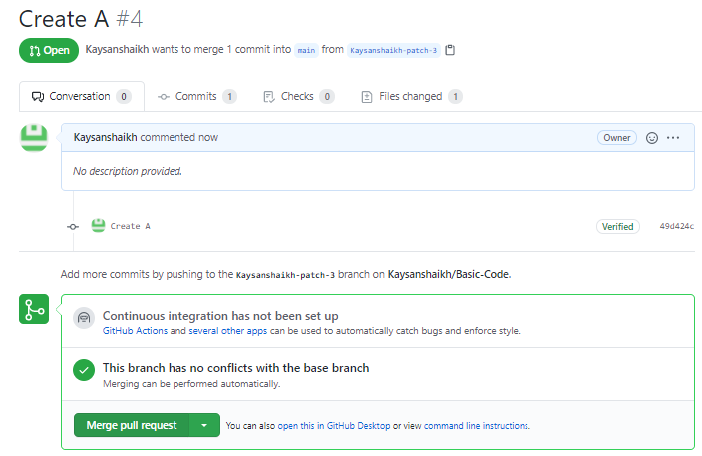

**10.Select the ‘Confirm merge’ option to merge.**

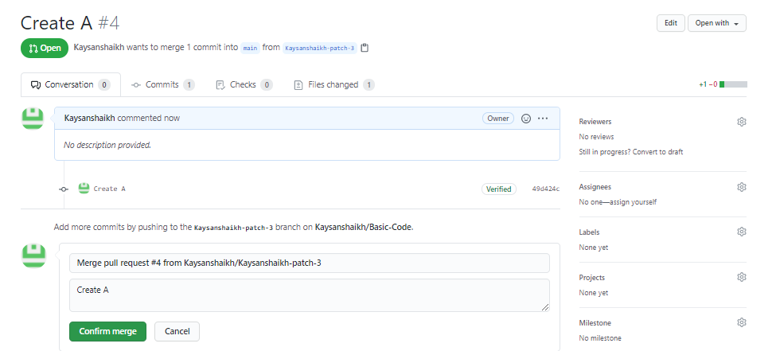

**11.Pull request successfully merged and closed.**

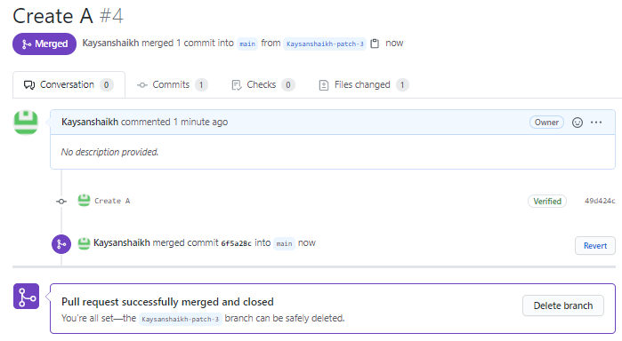

**Practical No: 04**

**Aim:** Create MySql Query where

1. Roll Number must be primary key and automitiacally increment by 1.
2. Age default value should be 20
3. UID should not be empty.
4. Demonstrate three different ways of inserting records.
5. Aggregate functions

**Queries:**

* show databases;
* use fyb;
* CREATE TABLE STUDENTS
* (roll_no int(20) Primary key NOT NULL
* AUTO_INCREMENT,
* NAME varchar(50),
* AGE int(10) DEFAULT 20,
* UID int(50) NOT NULL);
* DESC STUDENTS;
* INSERT INTO STUDENTS
* (roll_no,NAME,AGE,UID) VALUES(1111,'Ramesh',17,2020262);
* INSERT INTO STUDENTS

(roll_no,NAME,AGE,UID) VALUES(1126,'Akash',18,2020253);

* INSERT INTO STUDENTS

(roll_no,NAME,AGE,UID) VALUES(1134,'Deepak',19,2020241);

* INSERT INTO STUDENTS VALUES (1146,'Kaysan',18,2020248);
* INSERT INTO STUDENTS VALUES (1147,'Mihir',18,2020650);
* INSERT INTO STUDENTS (roll_no,NAME,AGE,UID) VALUES (1156,'Janhavi',19,2020205);
* INSERT INTO STUDENTS (roll_no,NAME,AGE,UID) VALUES (1162,'Kaheesha',18,2020555);
* INSERT INTO STUDENTS (roll_no,NAME,AGE,UID)
* VALUES(1164,'Scientilla',20,2020626),(1165,'Akshata',19,2020710),(1166,'Sushmita',17,2020722);
* Select * from students;

#### **1.Creating MySQL table**

#### 

#### The CREATE TABLE statement is used to create a new table in a database

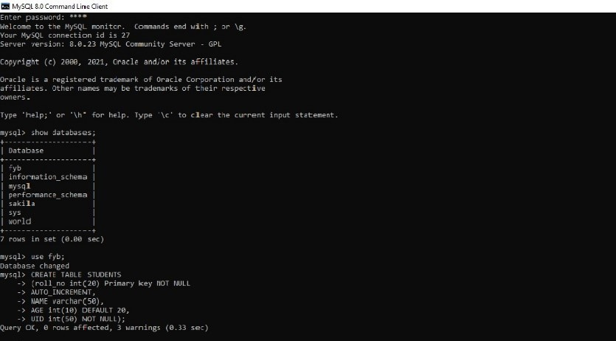

**2.Demonstrate the three different ways of Inserting records:**

The INSERT INTO statement is used to insert new records in a table. It is possible to write the INSERT INTO statement in following ways:

* 1. *Specifying both the columns names and the values to be inserted.*

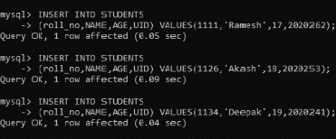

* 1. ***Not specifying the column names. Only specifying the values.***





* 1. ***Inserting data only in specifies columns.***

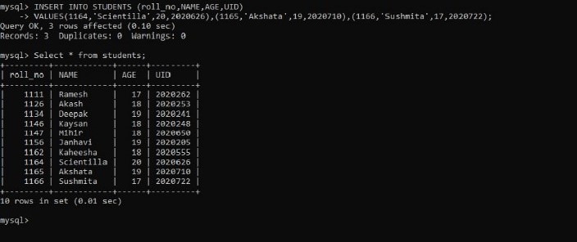

**3. Aggregate functions**

***COUNT Function- The COUNT () function returns the number of rows that matches a specified criterion.***

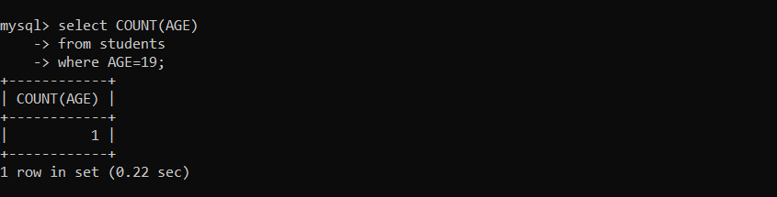

***SUM function- The SUM () function returns the total sum of a numeric column.***

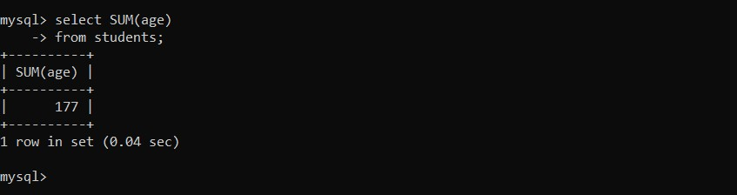

***AVG Function- The AVG () function returns the average value of a numeric column value of the selected column.***

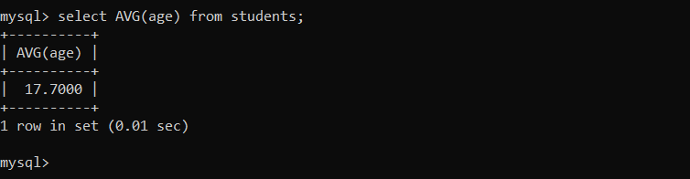

***MIN and MAX function- The MIN() function returns the smallest value of the selected column. The MAX() function returns the largest***

Page **17** of **25**

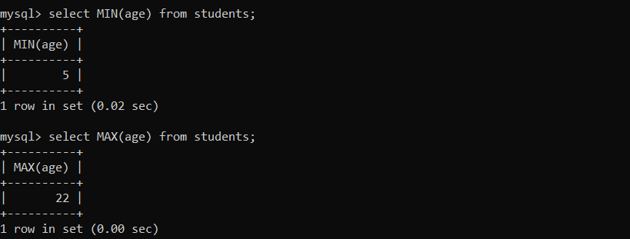

**Practical No: 05**

**Aim:** Create SQL query to alter three more columns and demonstrate the use of all the keywords use select command after adding 10 records. Use the following commands:

1. SELECT
2. AS
3. FROM
4. WHERE
5. IN()
6. LIKE
7. IS NULL
8. IS NOT NULL
9. Distinct
10. Limit
11. Order By
12. Aggregate
13. Group By
14. Having

**Query:**

* **show databases;**
* **use fyb;**
* **select * from students;**
* **alter table students**

**add class varchar(10);**

* **alter table students**

**add division varchar(2);**

* **alter table students**

**add total_marks int(2);**

* **desc students;**
* **insert into students;**

**(name,uid,class,division,total_marks)**

**Values(‘Anjali’,1120,‘fy-bsc’,‘cs’,97), (‘Kalpesh’,1121,‘fy-bsc’,‘cs’,98)**

**;**

* **insert into students;**

**(name,uid,class,division,total_marks)**

**Values(‘Ananya’,1131,‘fy-bsc’,‘cs’,57), (‘Dript’,1124,‘fy-bsc’,‘cs’,100);**

* **update student**

**set class=‘fy-bsc’, division=‘cs’,total_marks=95**

**where roll_no=1170;**

* **select * from students;**
* **select total_marks from students where roll_no <1164;**
* **select total_marks from students where roll_no >1164;**
* **select roll_no AS id from students;**
* **select * from students where division IN (‘cs’);**
* **select * from students where class IN (‘fy-bsc’);**
* **select * from students where LIKE ‘a%’;**
* **select * from students WHERE name IS NULL;**
* **select * from students WHERE name IS NOT NULL;**
* **select DISTINCT AGE from students;**
* **select * from students**
* **ORDER BY total_marks desc;**
* **SELECT**

**-> AVG(AGE)**

**-> FROM**

**-> students;**

* **select count(age),division from students Group by division HAVING count(age)>5;**
* **select count(age),division from students Group by division HAVING count(age)<5;**

#### **1)Altering and updating the table named students then select * from students; which displays all the entries in the table:**

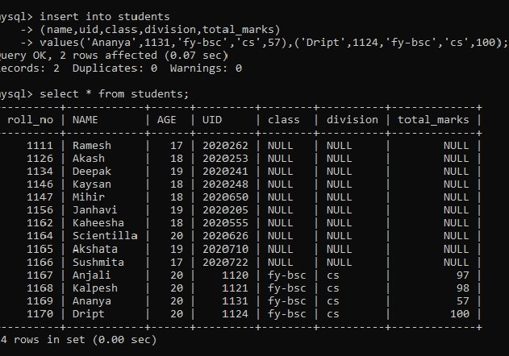

1. **select roll_no AS id from students;**

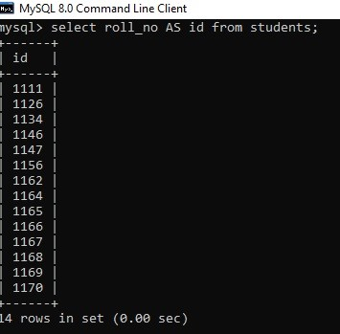

1. **select name,age FROM students;**

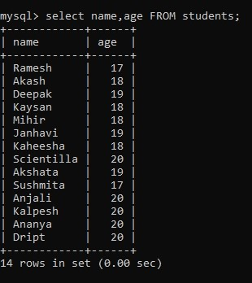

1. ***select total_marks from students where roll_no <1164 or Select total_marks from students where roll_no><1164***

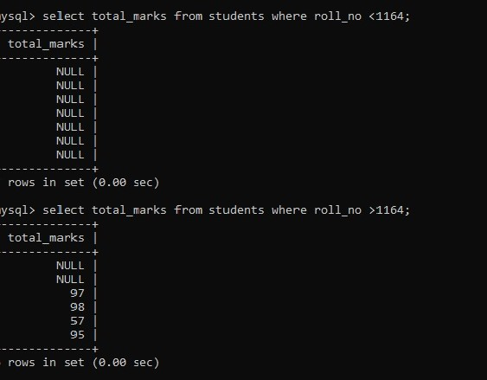

***5) select * from students where division IN ('cs') or select * from students where class IN ('fy-bsc’);***

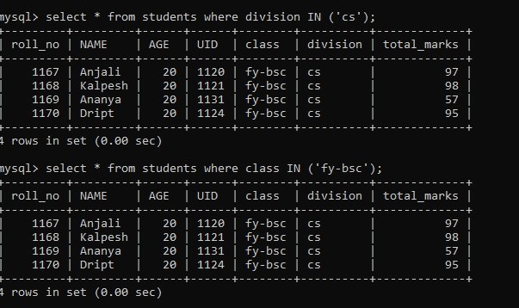

***6) select * from students WHERE name LIKE 'a%' or select * from students WHERE name LIKE 'a%';***

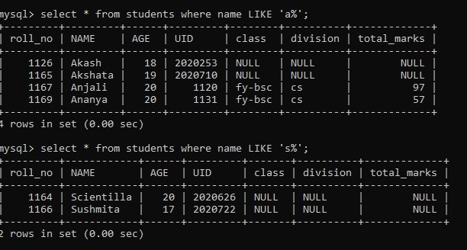

1. ***select * from students WHERE name IS NULL;***

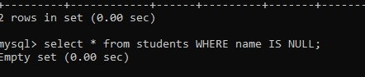

1. ***select * from students WHERE name IS NOT NULL;***

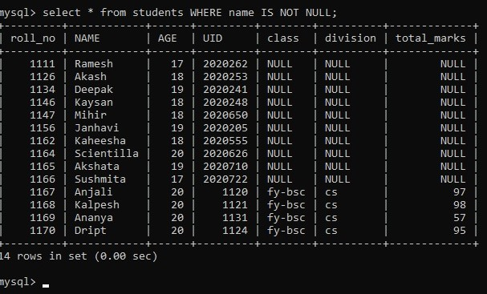

***9) select DISTINCT AGE from students;***

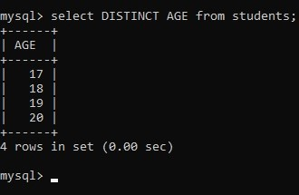

1. ***select * from students LIMIT 6;***

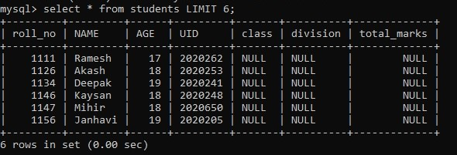

***11) select * from students ORDER BY total_marks desc;***

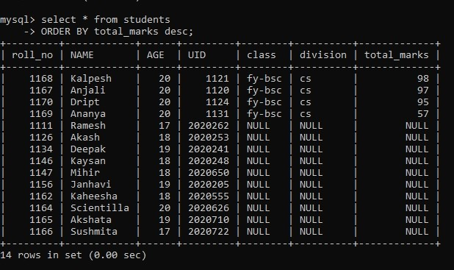

***12) SELECT***

***-> AVG(AGE)***

***-> FROM***

***-> students;***

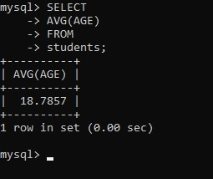

***13) select count(age),division from students GROUP BY division;***

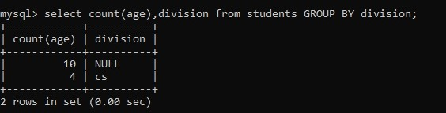

***14) select count(age),division from students Group by division HAVING count(age)>5;***

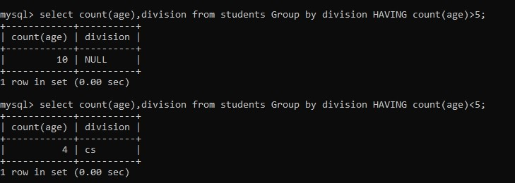

**Practical No: 06**

**Aim:** 1) Introduction to Wikipedia

2) Create User account in Wikipedia

3) Contribute to Wikipedia

***1) Introduction to Wikipedia***

Wikipedia is a free, [multilingual](https://en.wikipedia.org/wiki/Multilingualism) [open-collaborative](https://en.wikipedia.org/wiki/Open_collaboration) [online encyclopedia](https://en.wikipedia.org/wiki/Online_encyclopedia) created and maintained by [a community of volunteer contributors](https://en.wikipedia.org/wiki/Wikipedians) using a [wiki](https://en.wikipedia.org/wiki/Wiki)-based editing system. Wikipedia is the largest general reference work on the [Internet](https://en.wikipedia.org/wiki/Internet),[[3]](https://en.wikipedia.org/wiki/Wikipedia#cite_note-Wiki20-5) and one of the 15 most popular websites as ranked by [Alexa](https://en.wikipedia.org/wiki/Alexa_Internet); in 2021, it was ranked as the 13th most-visited.[[4]](https://en.wikipedia.org/wiki/Wikipedia#cite_note-Alexa_siteinfo-6)[[note 3]](https://en.wikipedia.org/wiki/Wikipedia#cite_note-8) The project carries no [advertisements](https://en.wikipedia.org/wiki/Online_advertising) and is hosted by the [Wikimedia Foundation](https://en.wikipedia.org/wiki/Wikimedia_Foundation), an [American non-profit organization](https://en.wikipedia.org/wiki/501(c)(3)_organization) funded mainly through donations.

Wikipedia was launched on January 15, 2001, by [Jimmy Wales](https://en.wikipedia.org/wiki/Jimmy_Wales) and [Larry Sanger](https://en.wikipedia.org/wiki/Larry_Sanger); Sanger coined its name as a [portmanteau](https://en.wikipedia.org/wiki/Portmanteau) of "wiki" and "encyclopedia". Initially available only in English, versions in other languages were quickly developed. The [English Wikipedia](https://en.wikipedia.org/wiki/English_Wikipedia), with 6.3 million articles as of April 2021, is the largest of the [321 language editions](https://en.wikipedia.org/wiki/List_of_Wikipedias). Combined, Wikipedia's editions comprise more than 56 million articles, and attract more than 17 million edits and more than 1.7 billion unique visitors per month.

***2) Create User account in Wikipedia***

***Go to Wikipedia account creation link and enter details as shown in the picture:***

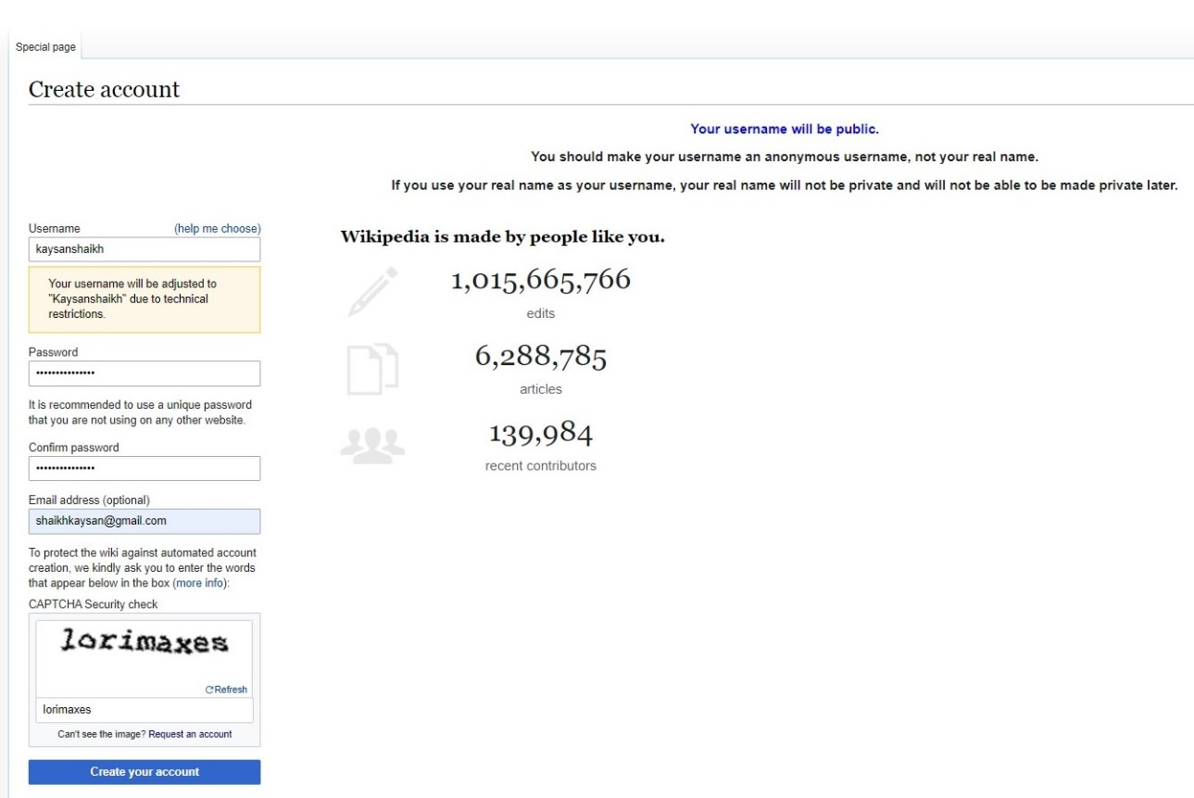

***This is how your account look after created.***

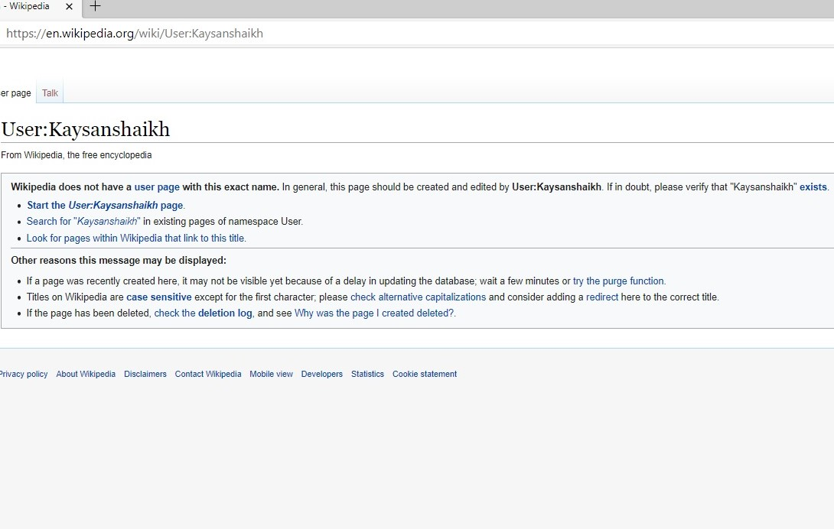

***3.Conribute to Wikipedia***

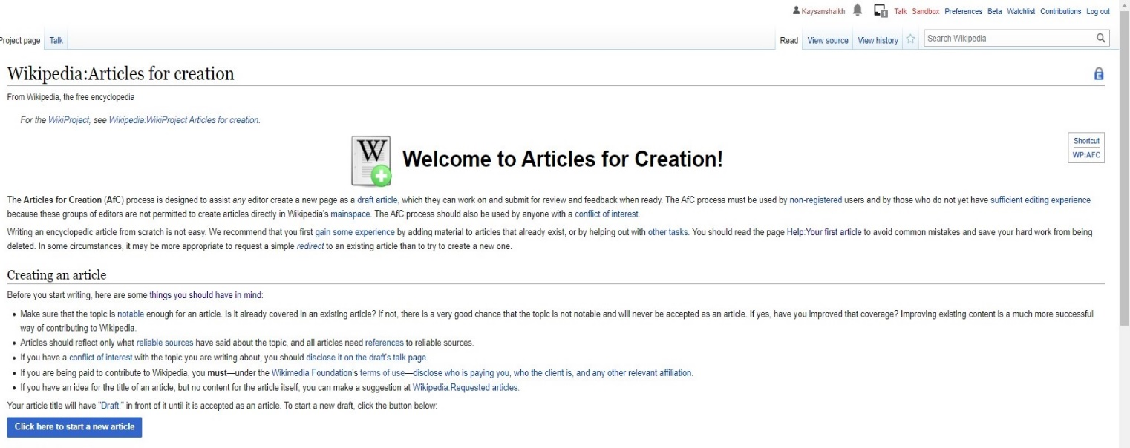**1st step: Go to ‘ask for it to be created’ link and you will be redirect to the page below, click on ‘click here to start a new article’.**

**2nd step:** **You will be redirected here and then choose the suitable option and complete all the required procedures as directed:**

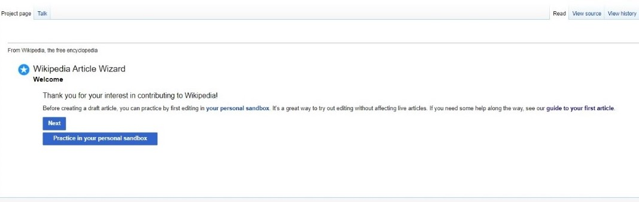

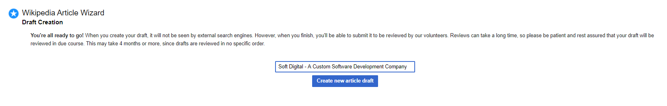**3rd Step: Enter the name of your Article to be drafted:**

**4th Step: Draft your Article Here and Publish it.**

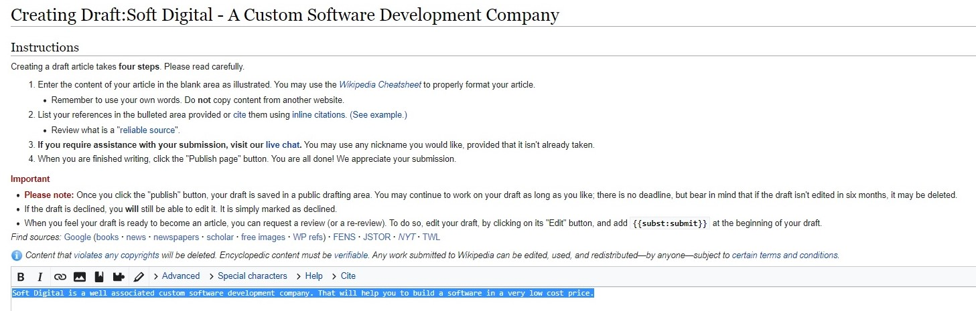

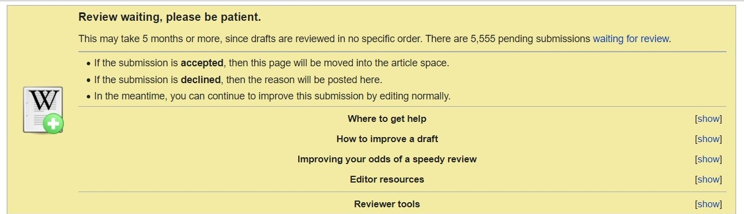**5th Step: You will be required to read the terms and conditions and your article will be drafted successfully.**